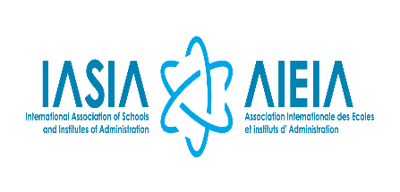

REGISTRATION FORM

8TH ANNUAL CONFERENCE OF THE AFRICA PUBLIC SECTOR-HUMAN RESOURCE MANAGERS NETWORK (APS-HRMnet)

Theme:
" Bringing citizens and government closer: The Role of Human Resource Management in Service delivery for social economic transformation”.

Venue:
Kenya School of Government

Date:
6th to 10th November 2023

Select Your Registration Type:

Kenyan Delegates (Participation Fee $ 400)

International Delegates (Participation Fee $ 500)

Participant’s Contact Information:
Salutation |  | Professor |  | Dr. |  | Mr. |  |  |  | Mrs. |  | Ms.
First Name: |  |  |  |  |  |  |  | Last Name:
Job Title:
Department:
Organization:
Work Phone: |  |  |  |  |  |  | Mobile:
Email:
Mailing Address:

Account Information:
Bank Name | Kenya Commercial Bank
Bank Branch | Sarit Centre Branch, Nairobi
Branch Code | 141
Account Name | Kenya School of Government
Account Number (USD Account) | 1107057957
Swift Code | 01141
VAT No. | 0125933R
PIN No. | P000634813M

Please return the completed form and evidence of payment of the Conference Fees to:

Either Or
Mr. Mark Sseremba  Executive Secretary, APS-HRMnet  +256.704664518  sserembamark@gmail.com | Dr. Prisca Oluoch,  Director of Linkages and Collaborations  Kenya School of Government  +254 720873606  Prisca.oluoch@ksg.ac.ke

